Escort the Michigan Traveling Wall
In The
2021 Run to the Fair
Thursday August 12, 2021
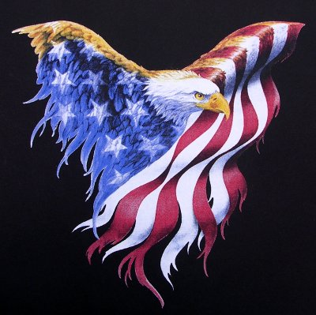
Gather at the Holiday Inn Express
3506 Oneil Dr. Jackson, MI 49202
Staging between 7:30 and 8:00 am

KICK STANDS UP AT 8:30

For information contact Dave Welihan 517-960-9268

